|  |
| --- |
|  |
| The Potato Game |
| You are never going to look at potatoes in the same way... |
| Version #03 |
| **Lisa Chiang & Luis Gutierrez Castillo** |
|  |

|  |
| --- |
| August 14, 2017 |

**Table of Contents**

Version History 4

I. Game Overview 5

II. Game Play Mechanics 5

III. Camera 6

IV. Controls 7

V. Interface Sketch 8

VI. Menu and Screen Descriptions 9

VII. Game World 11

VIII. Levels 11

IX. Game Progression 13

X. Characters 14

XI. Non-player Characters 14

XII. Hazards 15

XIII. Items 16

XIV. Script 17

XV. Scoring 18

XVI. Art / Multimedia Index 18

XVII. Future Features 20

# Version History

Version #01: Basic Elements of the Game

Version #02: New Updates and Details

Version #03: Final Version

# Game Overview

Billy “The Tarte” is a potato and he lives in Veggietown. He’s never without his bike, which he uses to go everywhere. He is always running away from Jeff “The Fryer”, a cutthroat cook from the neighbour town Fastfoodville, who wants to turn him into french fries to sell at his restaurant.

Today Billy is in trouble. During one of his escapes by bike, his brakes break. The problem is that he’s on a slope and he cannot stop! Furthermore, the road is in very bad shape and full of obstacles. It’s time to stay cool. Avoid the hazards, control the bike handlebars until the end of the slope, and save Billy and his bike.

# Game Play Mechanics

While going down the hill, Billy needs to veer his bike from a side to the other of the road to avoid the hazardous obstacles. The way is insidious, and skillfully dodging the dangers ensures our hero to reach the end of the slope all in one piece.

Here follows a table with some example images.

|  |  |  |
| --- | --- | --- |
| **Mechanic** | **Description of Mechanic** | **Images of Mechanic** |
| Avoid Obstacle | Move the bike (to the right or the left) to make Billy dodging the holes or pedestrians on the road |  |

# Camera

This camera of the game is a top-down camera. In fact, the player can see the whole game scene from the top point of view, which includes the rider, the bike, the road, the obstacles.

# Controls

The user can control the orientation of the bike during the race by using the left key arrow to move the bike to the left and the key right arrow to move it to the right. Billy will continue towards the selected until the player lifts the finger.

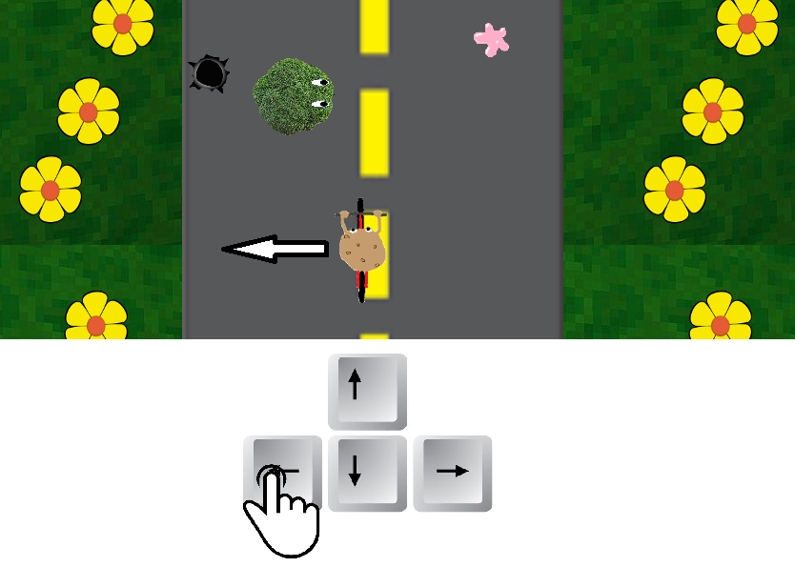

*Figure 1: player press left arrow key and Billy move towards left.*

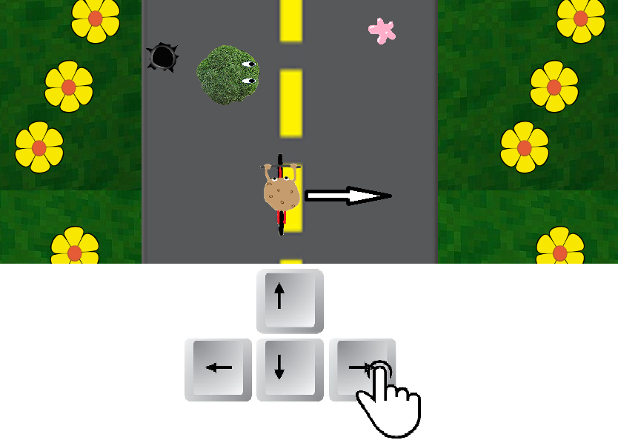

*Figure 2: player press right arrow key and Billy move towards right.*

# Interface Sketch

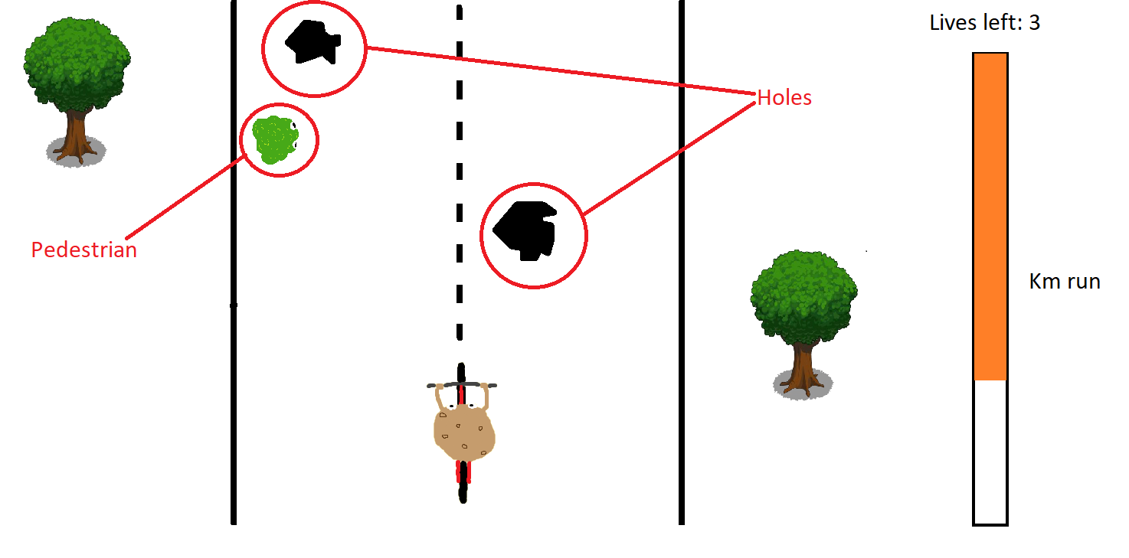

*Figure 3: game interface*

The road is in vertical position and the player will have the feeling of riding from the bottom towards the top of the screen. On both sides of the road there is the landscape of the world (cactuses, flowers, grass).

On the top right corner of the interface there is a label that shows to the player how many lives there are left for the current level.

On the right, a bar shows the remaining distance to run to reach the end of the slope and pass the level.

# Menu and Screen Descriptions

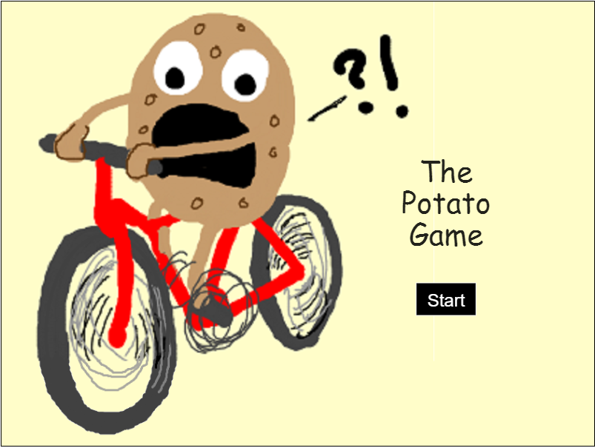

*Figure 4: main menu screen*

This is the view that the player will see when the whole game is started. By pressing the button “Start”the player passes to the Instruction screen.

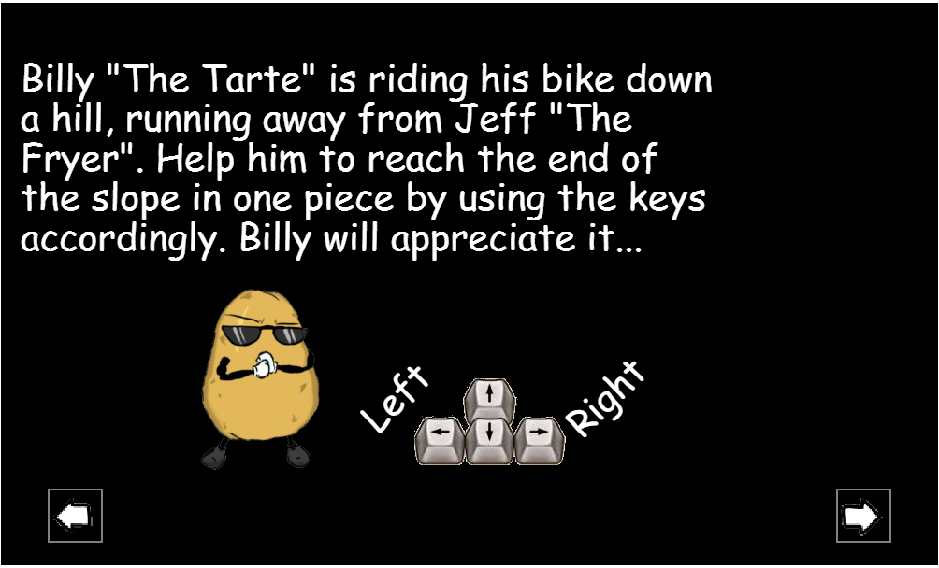

*Figure 5: controls screen*

This screen is visualized right before the actual game starts. In these screen the instruction to play are described. By pressing the button “<--” the player can come back to the main menu, and by pressing the button “-->” the player can start to play.

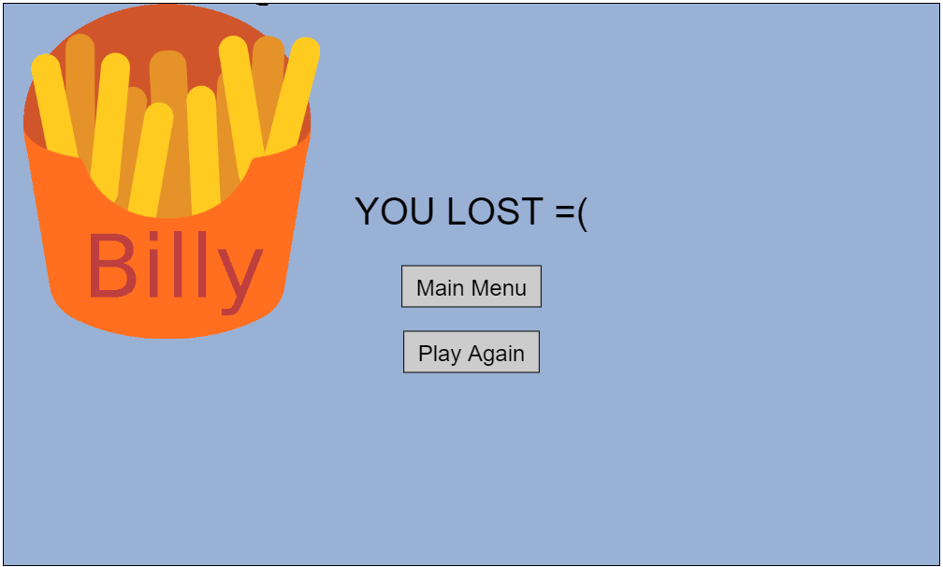

*Figure 6: game over screen*

This screen is visualized when the player loses all the lives in a level. From here it is possible to go back to the main menu or to play again directly.

# Game World

Veggietown exists in an imaginary world where the citizens are all vegetables, who live happily together. This town is where the game is set and it is constituted by a mix of roads and natural elements, such as cactuses or flowers.

** **

*Figure 7: cactus and flower*

# Levels

The game is constituted by 3 levels, and the difficulty of the game increases with the progression of the levels.

1. Level 1 - Billy has to avoid holes on a road in the middle of the desert with cactus. Oil spots and chewing gums can be occasionally found on the way. 3 lives are available.

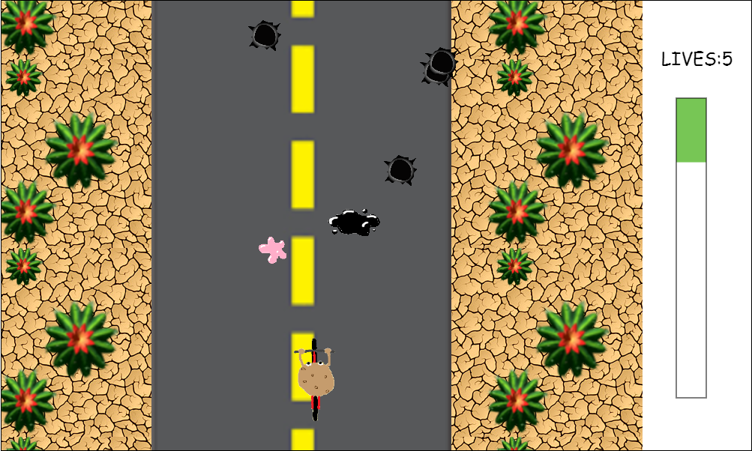

*Figure 8: level 1 game screen*

1. Level 2 - Billy gets to a even more steep slope and is running faster. The mission becomes more challenging on the slope of the green hill, as the speed increases of 50%. Billy will take the same time of the previous level to reach the bottom. In addition to holes, also pedestrians can obstacle the run flow. Also in this level, oil spots and chewing gums can be occasionally found. 5 lives are available.

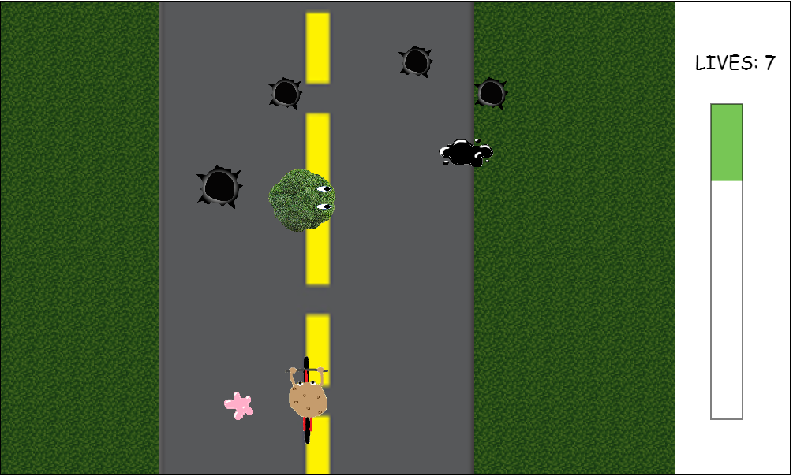

*Figure 9: level 2 game screen*

1. Level 3 - Billy ends up on a hill full of yellow flowers, and the steeper road makes him go 50% faster than in level 2. Billy will take the same amount of time of the other levels to reach the end. Holes, oil spots, and chewing gums are on the way, and pedestrians will cross the street occasionally and unexpectedly. 8 lives are available.

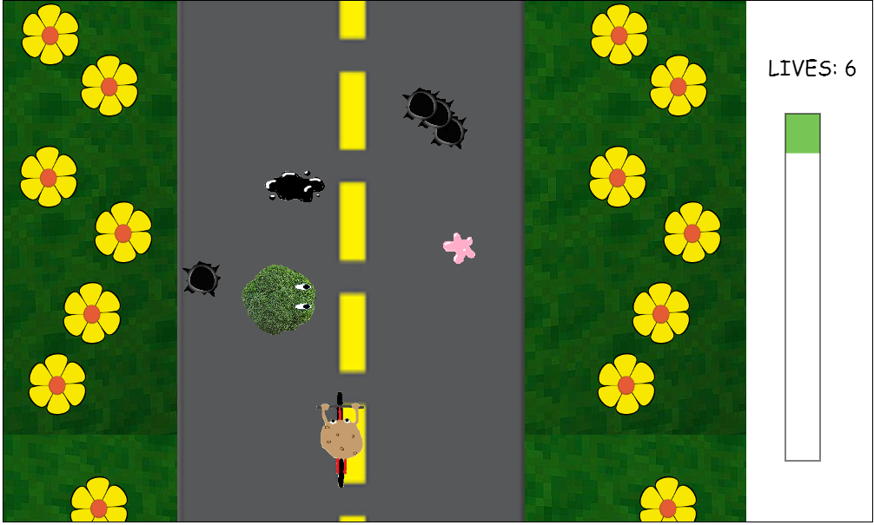

*Figure 10: level 3 game screen*

# Game Progression

The player always starts from level 1. The progression of the game just follows the order of the levels. Once the player has passed a level, the next level is played. The player can pass a level just if able to take Billy at the end of the slope in one piece, without consuming all the 3 lives available. At the beginning of a new level, the number of lives is resetted and the player has 3 lives again.

# Characters

*Billy “The Tart” -* He is the main character of the video game, always with his inseparable bike. Billy and his bike are the object that needs to be controlled by the player.

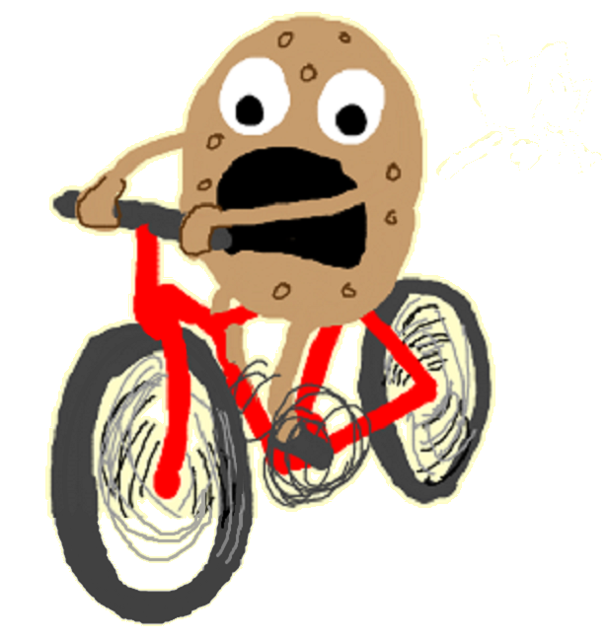

*Figure 11: Billy “The Tarte”*

# Non-player Characters

*Jeff “The Fryer”* - He is the villain of the video game story. Jeff is obsessed by catching Billy to make some french fries of him. He wants to sell the fries to his customers at his restaurant in Fastfoodville.

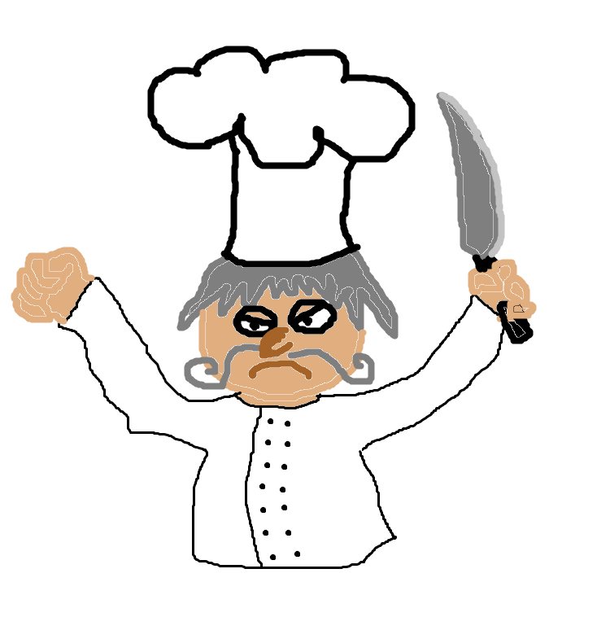

*Figure 12: Jeff “The Fryer”*

*Pedestrians* - They are citizens of Veggietown. They are all vegetables crossing the streets at random times. They will obstacle the Billy’s run.

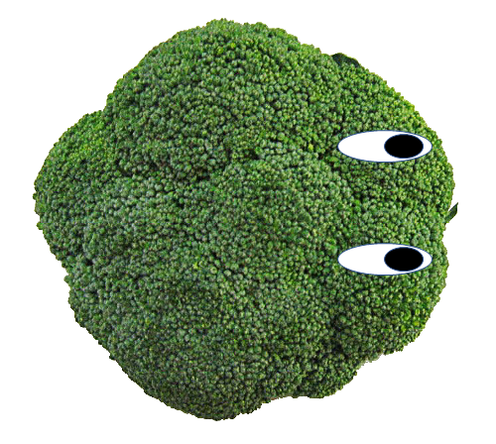

*Figure 13: Pedestrian (broccoli)*

# Hazards

*Holes -* They are holes on the road asphalt. They will appear at random moments in random spots of the slope. Whenever Billy’s bike hits them during the run, Billy will fall on the ground, and the player will lose a life. If there are lives left, Billy restarts the run from the spot of the fall.



*Figure 14: Hole*

*Oil spots* - They are motor oil spots on the ground. Whenever Billy’s bike touches them during the run, the bike will run faster for 5 seconds, making the duty of avoiding the obstacle more difficult.



*Figure 15: Oil spot*

# Items

*Chewing gums* - They are used chewing gums left on the road. If the player touches one of them with the bike, the descent will be slowed down for 5 seconds and the race will be less crazy for while.



*Figure 16: Chewing gum*

# Script

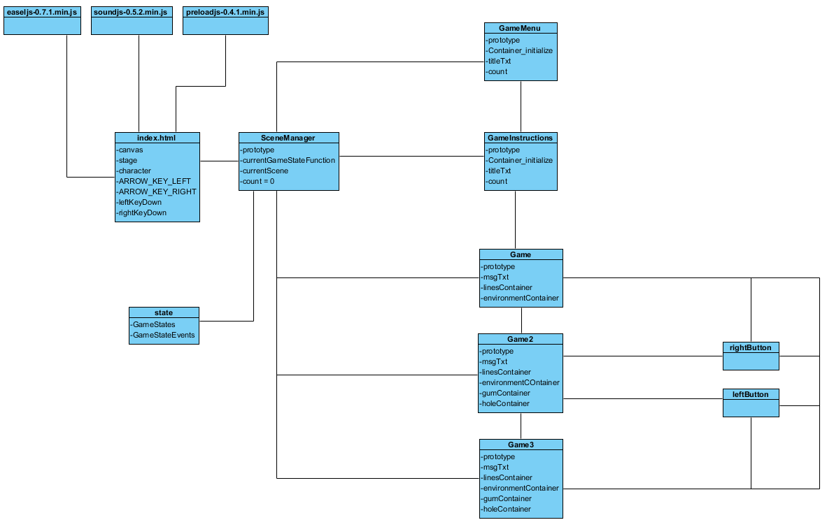

*Figure 17: UML diagram of the project files structure*

In this diagram we can see the relationship between the files created for the game and a list of the elements contained in those files. The file “index.html” uses different class libraries (easelJs, soundJs, preloadJs).

“SceneManager.js” is the first level class called by “index.html”. Then, “SceneManager.js” will call “GameMenu.js” as the main entrance of the game. “GameMenu.js” allows to call “GameInstructions.js”. The last one will allow to call “Game.js”, which contains the level 1 game scene. From “Game.js” is possible to go to “Game2.js”; “Game2.js” allows to call “Game3.js”.

# Scoring

The score is represented by the level of completion of the distance bar. The green part is the completed distance. When the bar becomes fully green, it means that the level has been completed and that the slope of that level has finished. At the beginning of a new level, the distance bar is empty, ready to be filled as Billy travels.

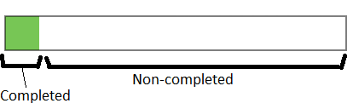

*Figure 18: distance bar*

# Art / Multimedia Index

* Potato on the bike shown in the menu screen (Figure 4)

From: <https://drawception.com/game/se2yR8kh2Q/potato-on-a-bike/>

By: Definetely Not Jazza

* Potato with sunglasses in the instruction screen (Figure 5)

From: <http://tirish.deviantart.com/art/Drawing-for-my-friend-Badass-Potato-279922133>

By: TiRiSh

* Road

From: <https://cliparts.zone/clipart/983695>

* Hole

From: <http://www.freepngimg.com/png/6873-bullet-shot-hole-png-image>

* French Fries

From: <http://www.emoji.co.uk/view/11648/>

* Yellow flower (level 3 environment)

From: <https://commons.wikimedia.org/wiki/File:RosendeutschschweizerBlatt.svg>

By: Kilom691

* Background music

title: No Brakes

Performer: The Offspring

Album: Americana

Year: 1998

Label: Columbia

* Background music

title: Come Out Swinging

Performer: The Offspring

Album: Conspiracy of One

Year: 2000

Label: Columbia

* Sound Effects

All effects were extracted from “Redneck Rampage” game, but ‘splash’ sound that was created.

Developers: Xatrix Entertainment

Publishers: Interplay Entertainment

Year: 1997

# Future Features

In the future versions of the game the following elements could be added:

* Spritesheet for the characters of the game.
* Better animations of the characters.
* Coins to collect on the way to accumulate actual points.
* An landscape with more details.